Hola a tod@s, esta es la tarea de Junio. Seguimos repasando. Las fichas, si es posible, se completan en el ordenador. Después, se envían el 19 de junio (como fecha límite) a este correo: inglesisa8@gmail.com Un saludo y muchas gracias por su esfuerzo.

Heroes and villains

1 Match the adjectives with their opposites.
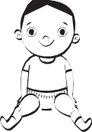
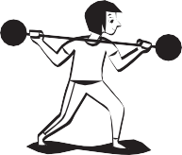
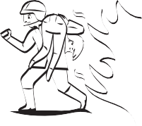
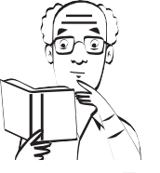
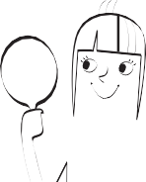

young

ugly
strong

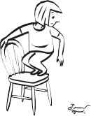
scared
pretty

silly
brave

old
wise

weak

2 Write and number.

- She isn’t young. ‡he’∫ old.
- 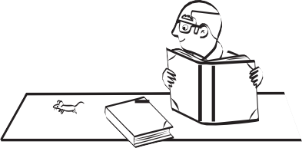He isn’t silly.
1
2
3
4
5
- She isn’t ugly.
- He isn’t brave.
- She isn’t weak.

3 Write about people you know. Use is or isn’t.
- (young) µy dad
- (old)
- (wise)
- (brave)
- (pretty)
- (strong)

Heroes and villains

Name
Support

1 Circle.
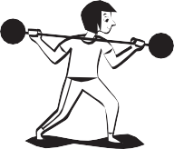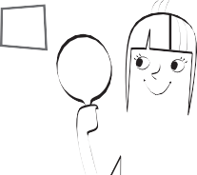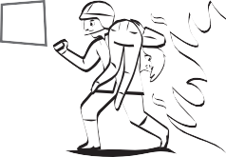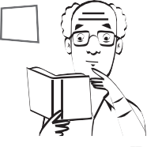
1
2
3
4
5

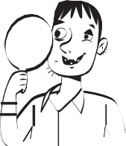young old
6

ugly pretty
strong weak

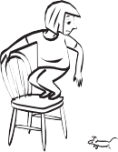
7
scared brave
ugly pretty

wise silly
8
scared brave

9
young old
wise silly

10
strong weak

2 Read and number.

- She’s old.
- 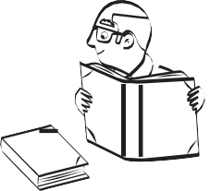He’s wise.
- She’s pretty.
- He’s scared.
- She’s strong.

3 Write about people you know. Use I’m or I’m not.
- (old) ý’m not old.
- (young)
- (brave)
- (silly)
- (strong)

Heroes and villains

Name
Reinforcement

1 Complete.
 |  | -er | -est
1 | old | older | oldest
2 | young |  | youngest
3 | strong | stronger
4 | wise | wiser
5 |  | braver | bravest

 |  | -er | -est
6 |  | sillier | silliest
7 | funny | funnier
8 | pretty |  | prettiest
9 | ugly | uglier
10 | happy |  | happiest

2 Read and circle True or False.

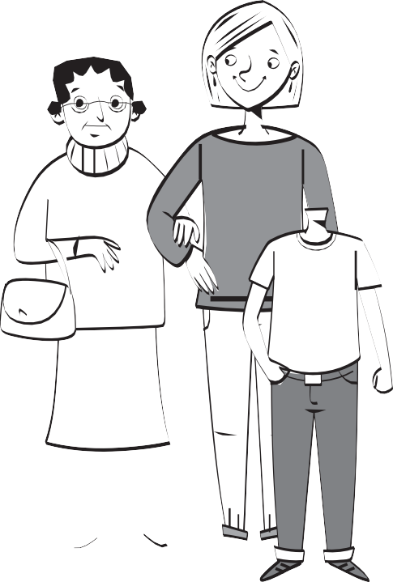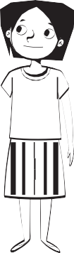
Granny Mum
Paul
Lucy
1 Lucy is younger than Paul. | True | False
2 Mum is older than Granny. | True | False
3 Granny is taller than Mum. | True | False
4 Paul is shorter than Mum. | True | False
5 Lucy is the shortest. | True | False
6 Paul is the happiest. | True | False
7 Granny is the tallest. | True | False
8 Granny is the oldest. | True | False

3 Correct the false sentences from activity 2.

Heroes and villains

Name
Extension

1 Complete.
 |  | -er | -est
1 | old | older | oldest
2 | young
3 | strong
4 | wise
5 | brave

 |  | -er | -est
6 | silly | sillier | silliest
7 | funny
8 | pretty
9 | ugly
10 | happy

2 Write sentences.

  - 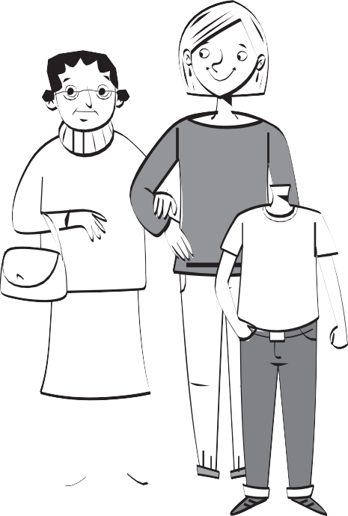Lucy / Paul / young
Lucy i∫ younger than ∏aul.
  - Mum / Granny / tall

  - Mum / Granny / old

  - Paul / Lucy / short

  - Paul / Granny / happy

Granny Mum

Paul Lucy

3 Write questions and answers.
- (tallest) ∑ho’∫ the tallest? Mum
- (shortest)
- (oldest)
- (youngest)
- (happiest)

ast times
P

Name
Catch-up

1 Match the adjectives with their opposites.
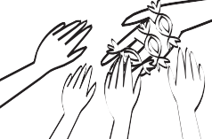
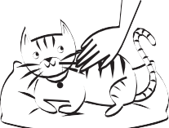
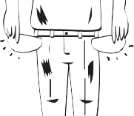

generous

rich
kind

thin
fat

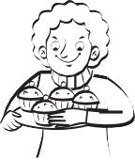
greedy
poor

quiet
noisy

cruel

2 Read and number.

- 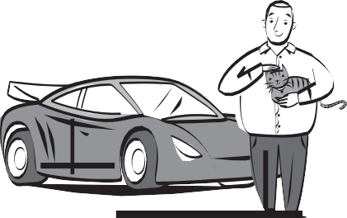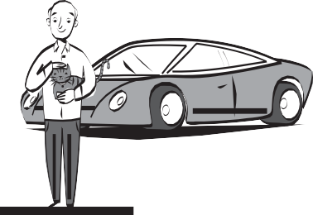He’s rich and kind. He isn’t fat.
- He’s thin and poor. He isn’t noisy.
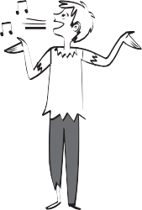
- He’s kind and fat. He isn’t poor.
- He isn’t rich and he isn’t fat. He’s noisy.

3 Write sentences with always, often, sometimes and never.

- (generous) ý’m generou∫.
- (kind)
- (noisy)
- (greedy)
- (quiet)

ast times
P

Name
Support

1 Circle.
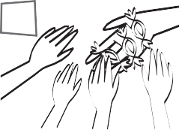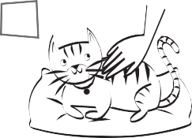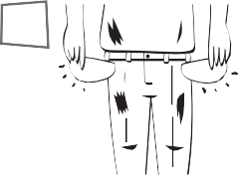
1
2
3
4
5

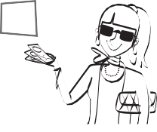generous greedy
6

poor rich
cruel kind
7

thin fat
thin fat

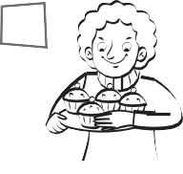
8

generous greedy
poor rich

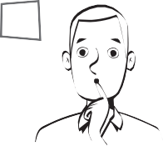quiet noisy
9
quiet noisy
10

cruel kind

2 Read and tick ✓ or cross ✗.
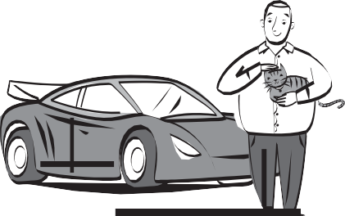

- He’s rich.
- He’s cruel.
- He’s fat.
- He’s rich.
- He’s quiet.
- He’s thin.

3 Choose and write.
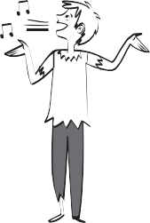
  - rich / poor ™e’∫
  - fat / thin
  - noisy / quiet

ast times
P

Name
Reinforcement

1 Match the opposites.
cruel fat greedy noisy poor

thin quiet kind rich generous
2 Read and complete.
play played use used listen listened watch watched

Yesterday after school …
- 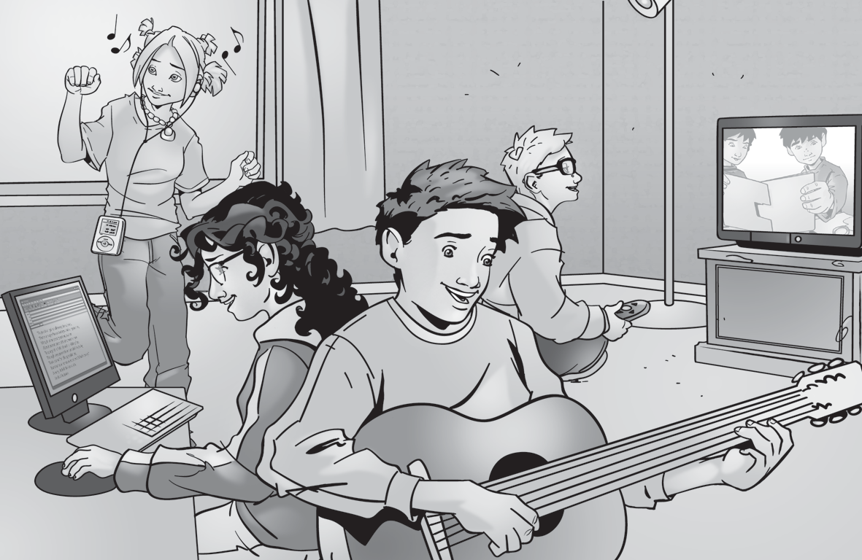Jo didn’t play the guitar. She listened to music.
Sam
Jo
Hannah
Rob
- Sam TV. He didn’t to music.
- Rob the guitar.
He the computer.

- Hannah TV. She the computer.
3 Answer the questions about yourself. Use Yes, I did or No, I didn’t.

- Did you play the guitar yesterday?
- Did you watch TV yesterday?
- Did you use the computer yesterday?
- Did you walk home from school yesterday?
- Did you talk to friends yesterday?
- Did you listen to music yesterday?

ast times
P

Name
Extension

1 Complete.
- The opposite of cruel.
 |  |  | 1 |  | 2
 |  |  |  |  |  |  | 3
 |  |  |  | 4
5

- The opposite of quiet.
- The opposite of fat.
- The opposite of poor.
- The opposite of generous.

2 Correct the sentences.
Yesterday after school …

- Jo watched TV.
Sam
Jo
Hannah
Rob
¯o didn’t watch †◊.
‡he

- Hannah played the guitar.

- Rob listened to music.

- Sam used the computer.

3 Answer the questions. Write.

After school yesterday …

- Did you walk home?
Yesterday after school, I

- Did you watch TV?

- Did you use the computer?

ife at home
L

Name
Support

1 Look and match.
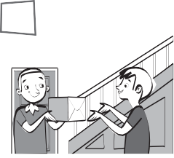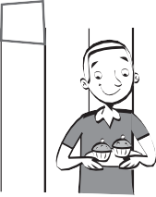
1
2
3
4
5

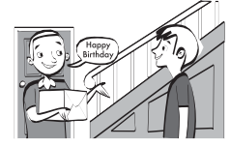
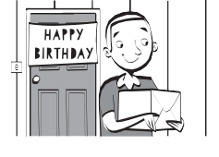
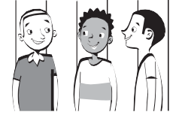
Yesterday …
- I went my friends.
- I said some cakes.
- I gave to Luke’s house.
- I saw Luke a present.
- I had ‘Happy Birthday’.
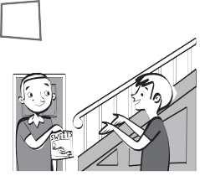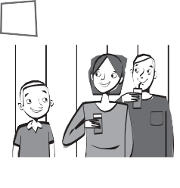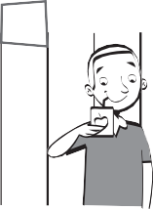
2 Look and write.
had said gave saw went
1
2
3
4
5

- I Luke some sweets.
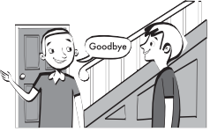
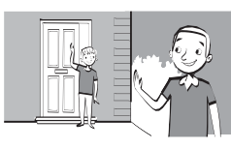
- I my aunty and uncle.
- I some fruit juice.
- I ‘goodbye’.
- I home.
3 Circle the past tense verbs.

say

ife at home
L

Name
Reinforcement

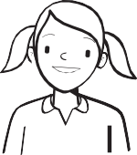
I didn’t go to Sally’s party, but I gave her some shells.
I went to Sally’s party, but I didn’t say Happy Birthday.
I said Happy Birthday, but I didn’t give her a present.
1 Write the past form of the verbs.
 | Present | Past
1 | I go | ý went
2 | I have
3 | I say

 | Present | Past
4 | I see
5 | I give
6 | I get up

2 Read and tick ✓ or cross ✗.

- Bill went to Sally’s party yesterday. But he didn’t have any money, so he didn’t give Sally a present. He gave her a card and he said Happy Birthday. Everyone had cake. He saw Sally’s mum and dad.
- Yesterday Tim went to Sally’s party. He gave her a present, but he didn’t say Happy Birthday. He had lots of party food and birthday cake. He saw Sally’s mum and dad. He went home at ten o’clock.
3 May didn’t go to Sally’s party because she was on holiday at the beach, so she didn’t have any birthday cake. When May got back from the beach she said Happy Birthday and gave her a present – some beautiful shells from the beach. She didn’t see Sally’s mum and dad.

 | went to party | gave a present | said Happy Birthday | had birthday cake | saw Sally’s mum and dad
Bill | ✓ | ✗
Tim
May

3 Read and write the names.

ife at home
L

Name
Extension

1 Complete.

I went | I | I | I | I
to a party.  home.  to school. | some cakes.  some water. | ‘hello’.  ‘goodbye’. | my friends.  my aunty. | my cousin a present.  my friend some sweets.

2 Complete. Use the verbs in brackets in the past.
- Bill went (✓ go) to Sally’s party yesterday. But he didn’t have (✗ have) any money, so he (✗ give) Sally a present. He gave her a card and he (✓ say) ‘Happy Birthday’. Everyone (✓ have) cake. He (✓ see) Sally’s mum and dad.
- Yesterday Tim (✓ go) to Sally’s party. He (✓ give) her a present, but he (✗ say) ‘Happy Birthday’. He (✓ have) lots of party food and birthday cake. He (✓ see) Sally’s mum and dad. He (✓ go) home at ten o’clock.
3 May (✗ go) to Sally’s party because she was on holiday at the beach, so she
(✗ have) any birthday cake. When May got back from the beach she (✓ say) ‘Happy Birthday’ and (✓ give) Sally a present – some beautiful shells from the beach. She (✗ see) Sally’s mum and dad.
3 Complete. Use the verbs in brackets in the past.
- did What yesterday? get time up you
∑hat time f l got up at
- breakfast time What you did morning? this have

- yesterday? bed time What go did to you

- this time you morning? get did What up

