Hola a tod@s, esta es la tarea de Junio. Seguimos repasando. Las fichas, si es posible, se completan en el ordenador. Después, se envían el 19 de junio (como fecha límite) a este correo: inglesisa8@gmail.com Un saludo y muchas gracias por su esfuerzo.

Heroes

1 Match the adjectives with their opposites.
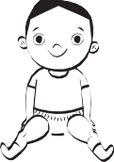
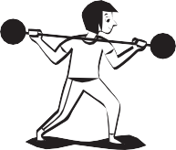
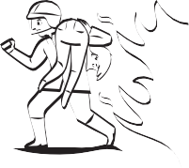
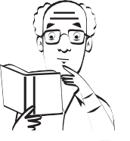
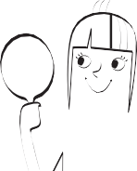

young

ugly
strong

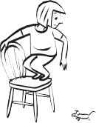
scared
pretty

silly
brave

old
wise

weak

2 Write and number.

- She isn’t young. ‡he’∫ old.
- 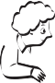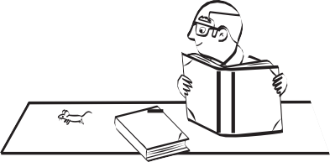He isn’t silly.
1
2
3
4
5
- She isn’t ugly.
- He isn’t brave.
- She isn’t weak.

3 Write about people you know. Use is or isn’t.
- (young) µy dad
- (old)
- (wise)
- (brave)
- (pretty)
- (strong)

Heroes and villains

Name
Support

1 Circle.
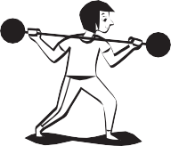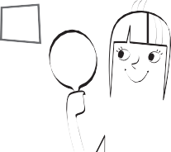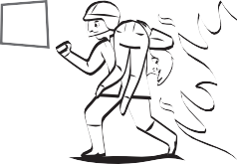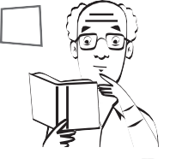
1
2
3
4
5

young old
6

ugly pretty
strong weak

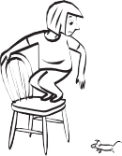
7
scared brave
ugly pretty

wise silly
8
scared brave

9
young old
wise silly

10
strong weak

2 Read and number.

- She’s old.
- 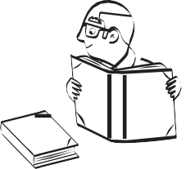He’s wise.
- She’s pretty.
- He’s scared.
- She’s strong.

3 Write about people you know. Use I’m or I’m not.
- (old) ý’m not old.
- (young)
- (brave)
- (silly)
- (strong)

Heroes and villains

Name
Reinforcement

1 Complete.
 |  | -er | -est
1 | old | older | oldest
2 | young |  | youngest
3 | strong | stronger
4 | wise | wiser
5 |  | braver | bravest

 |  | -er | -est
6 |  | sillier | silliest
7 | funny | funnier
8 | pretty |  | prettiest
9 | ugly | uglier
10 | happy |  | happiest

2 Read and circle True or False.

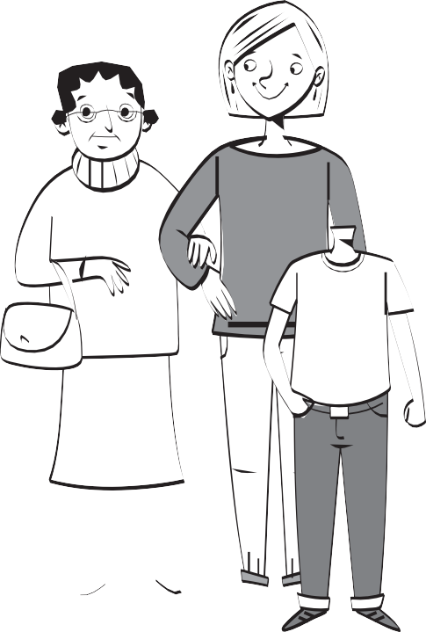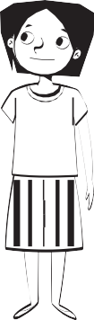
Granny Mum
Paul
Lucy
1 Lucy is younger than Paul. | True | False
2 Mum is older than Granny. | True | False
3 Granny is taller than Mum. | True | False
4 Paul is shorter than Mum. | True | False
5 Lucy is the shortest. | True | False
6 Paul is the happiest. | True | False
7 Granny is the tallest. | True | False
8 Granny is the oldest. | True | False

3 Correct the false sentences from activity 2.

Heroes and villains

Name
Extension

1 Complete.
 |  | -er | -est
1 | old | older | oldest
2 | young
3 | strong
4 | wise
5 | brave

 |  | -er | -est
6 | silly | sillier | silliest
7 | funny
8 | pretty
9 | ugly
10 | happy

2 Write sentences.

  - 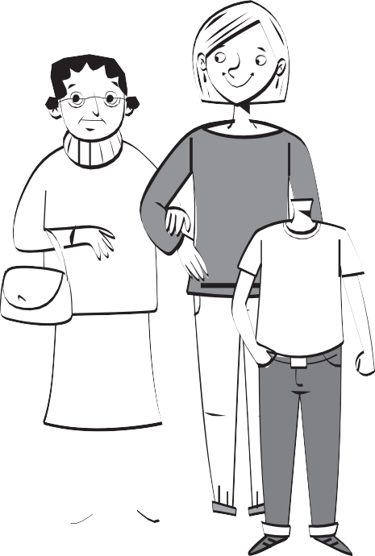Lucy / Paul / young
Lucy i∫ younger than ∏aul.
  - Mum / Granny / tall

  - Mum / Granny / old

  - Paul / Lucy / short

  - Paul / Granny / happy

Granny Mum

Paul Lucy

3 Write questions and answers.
- (tallest) ∑ho’∫ the tallest? Mum
- (shortest)
- (oldest)
- (youngest)
- (happiest)

ast times
P

Name
Catch-up

1 Match the adjectives with their opposites.
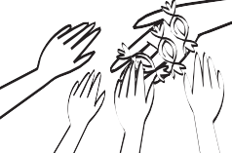
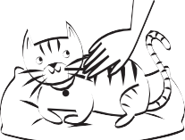
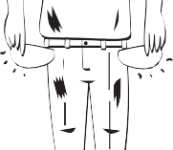

generous

rich
kind

thin
fat

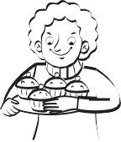
greedy
poor

quiet
noisy

cruel

2 Read and number.

- 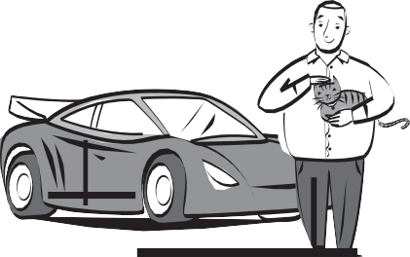He’s rich and kind. He isn’t fat.
- He’s thin and poor. He isn’t noisy.
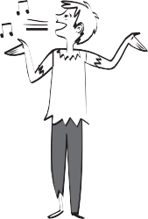
- He’s kind and fat. He isn’t poor.
- He isn’t rich and he isn’t fat. He’s noisy.

3 Write sentences with always, often, sometimes and never.

- (generous) ý’m generou∫.
- (kind)
- (noisy)
- (greedy)
- (quiet)

ast times
P

Name
Support

1 Circle.
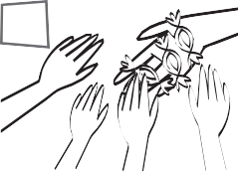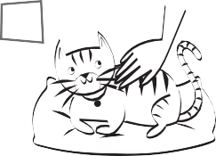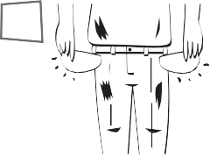
1
2
3
4
5

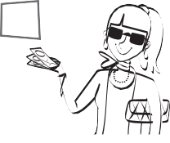generous greedy
6

poor rich
cruel kind
7

thin fat
thin fat

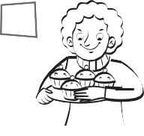
8

generous greedy
poor rich

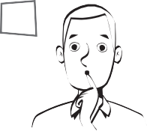quiet noisy
9
quiet noisy
10

cruel kind

2 Read and tick ✓ or cross ✗.
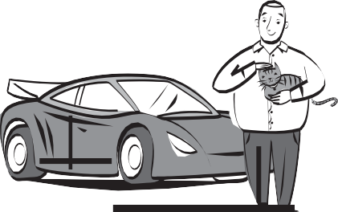

- He’s rich.
- He’s cruel.
- He’s fat.
- He’s rich.
- He’s quiet.
- He’s thin.

3 Choose and write.
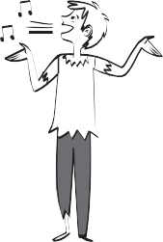
  - rich / poor ™e’∫
  - fat / thin
  - noisy / quiet

y country
M

Name
Catch-up

1 Find, write and number.
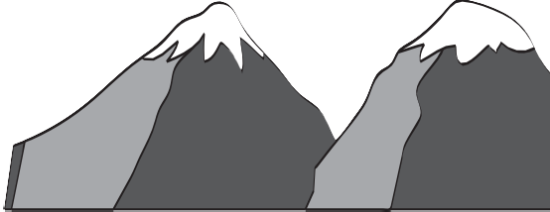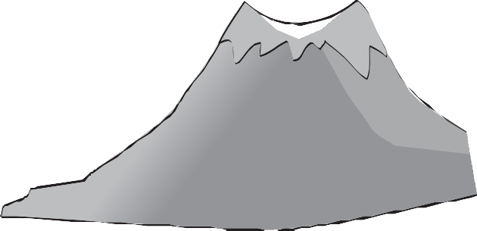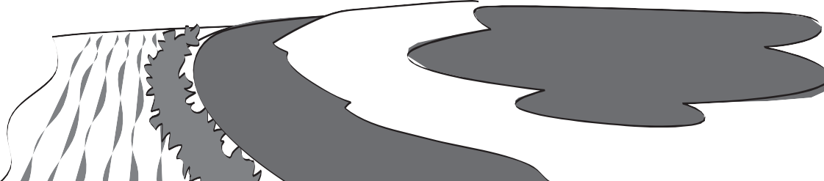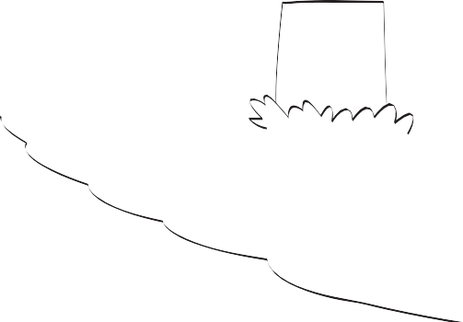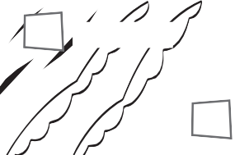
1 a volcano
2 mountains
3
hills
10 an island
6 a waterfall
9 an ocean
7 a lake
8 a beach
5 a river
4 a jungle

gujeln jungle
4
dansli islhl
ecbah coalvon
necoa
traflewal untimason
kale evrir

2 Look and write
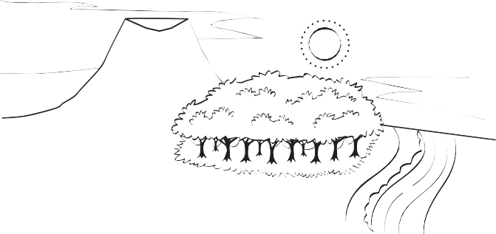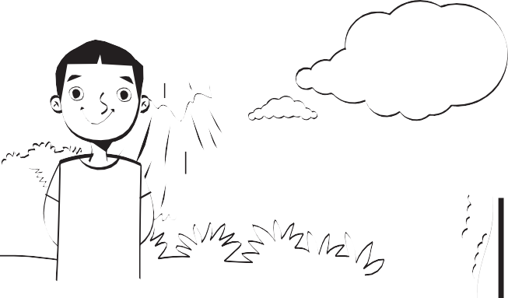†hi∫ i∫ a photo of me. ý’m standing in front of a . Next to the volcano there’∫ a .
¥ou can see a and an
, too.

3 Draw your own picture. Write.

This is a picture of me. I’m standing in front of

. Next to the there

. You can see and

, too.

ife at home
L

Name
Support

1 Look and match.
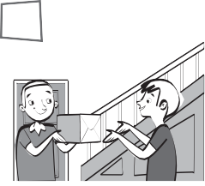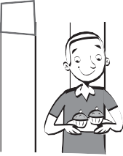
1
2
3
4
5

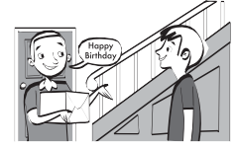
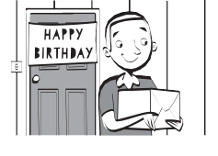
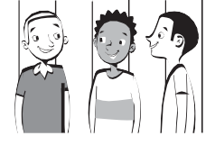
Yesterday …
- I went my friends.
- I said some cakes.
- I gave to Luke’s house.
- I saw Luke a present.
- I had ‘Happy Birthday’.
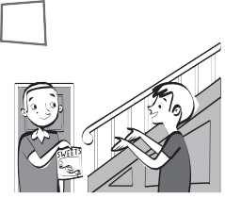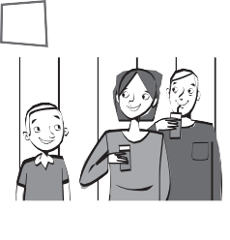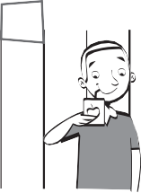
2 Look and write.
had said gave saw went
1
2
3
4
5

- I Luke some sweets.
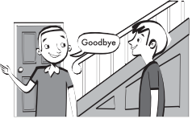
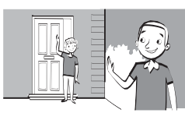
- I my aunty and uncle.
- I some fruit juice.
- I ‘goodbye’.
- I home.
3 Circle the past tense verbs.

say

y country
M

Name
Support

1 Find and number.
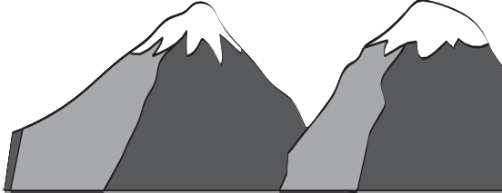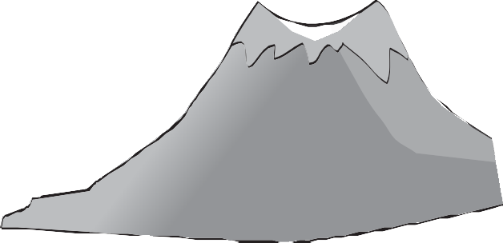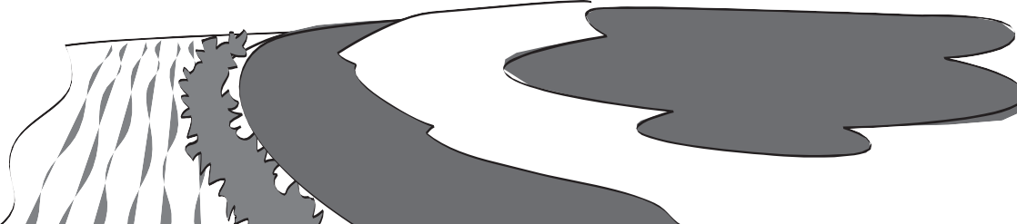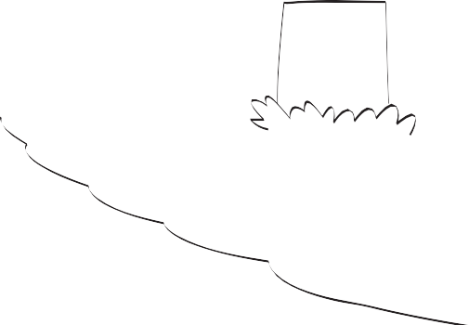
7
6
5
8
4
2
3
9
1
10

a beach mountains
1
a jungle

a waterfall
an island a volcano
a lake

an ocean
hills

a river

2 Read and write A or B.

  - 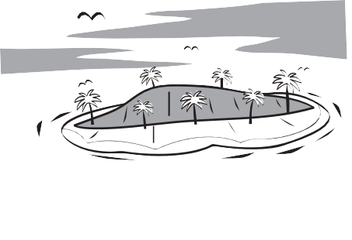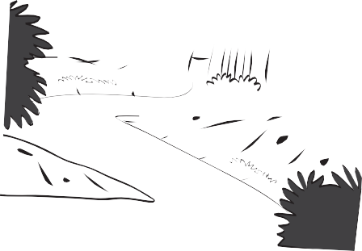You can see a river.
∆
  - You can see a beach.
  - You can see an island.
  - You can see a waterfall.
  - You can see an ocean.
  - You can see hills.
3 Look and write

- 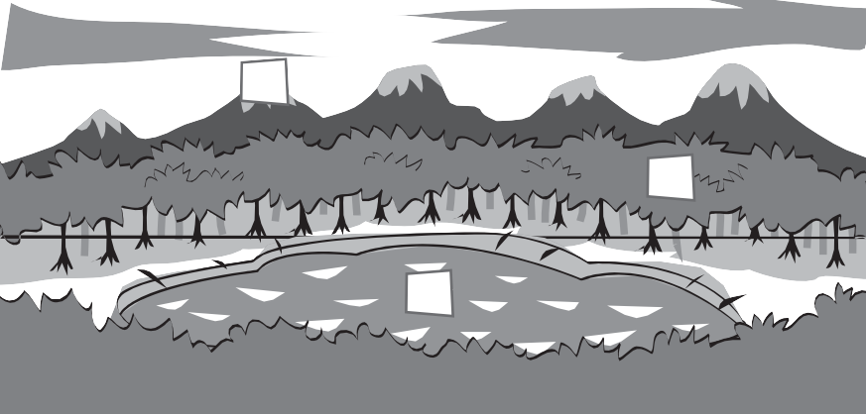You can see
1
3
2
- You can see
- You can see

y country
M

Name
Reinforcement

2 Circle the correct word.
1 Match.

3 Write True or False.
- When I was four, my favourite toys were a car and a scooter.
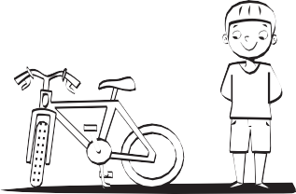
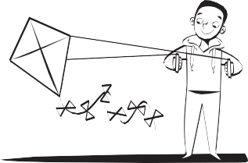
- Now, my favourite toy is a kite.

- When I was four, my favourite food was ice cream.
- Now, my favourite foods are chicken and
salad.

y country
M

Name
Extension

1 Write.

- Loch Ness in Scotland is a famous lake .
- You can ski in the m .
- The Atlantic is an o .
- Mallorca is an i .
- The Nile is a r .
- The Victoria Falls are famous w .
am
- There are lots of trees and animals in the j .
- El Hierro is a v .
- A small mountain is called a h .
- You can play volleyball on the b .

2 Complete with am, are or is.

3 Complete.
  - When I was four, my favourite toy

  - Now, my favourite toy

  - When I was four, my favourite food

  - Now, my favourite foods

