Hola a tod@s, esta es la tarea de Junio. Seguimos repasando. Las fichas, si es posible, se completan en el ordenador. Después, se envían el 19 de junio (como fecha límite) a este correo: inglesisa8@gmail.com Un saludo y muchas gracias por su esfuerzo.

1 Read and say. Look and write.

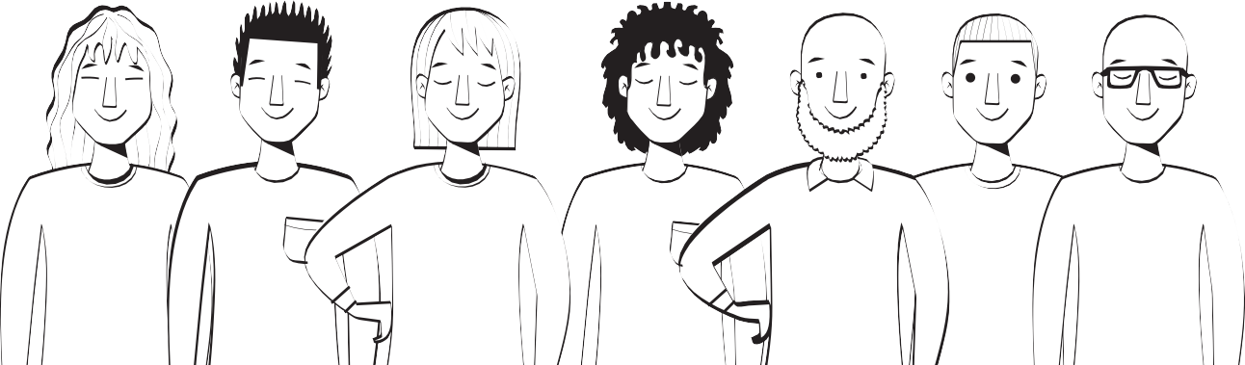
long
short
straight
curly
small, beard big, fringe
glasses

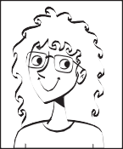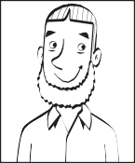
Hair:
long
Eyes:

Other:
Hair: Eyes: Other:
2 Circle the odd one out. Write.
1 He hasn’t got a beard.

2
She’s got

3
She hasn’t got

4
He’s got

3 Answer about yourself. Use Yes, I have or No, I haven’t.
- Have you got a beard? ˙o, I haven’t.
- Have you got short hair?
- Have you got curly hair?
- Have you got a fringe?
- Have you got big eyes?
- Have you got glasses?

Family and friends

Name
Support

1 Match.
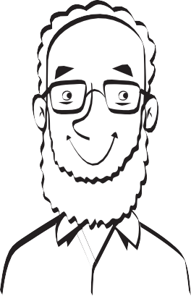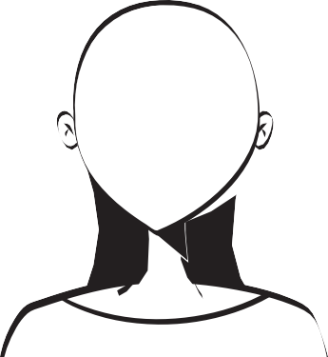short hair long hair straight hair curly hair big eyes small eyes a beard
a fringe glasses
2 Read and circle.

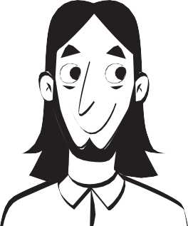
  - He’s got
big
/ small eyes.

  - He’s got long / short hair.
  - He’s got glasses / a beard .

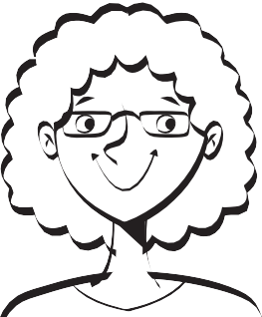
  - She’s got big / small eyes.
  - She’s got straight / curly hair.
  - She’s got glasses / a fringe .

3 Look and write.

- She’s got eyes.
- She’s got hair.
- She’s got a

Family and friends

Name
Reinforcement

1 Find and circle.
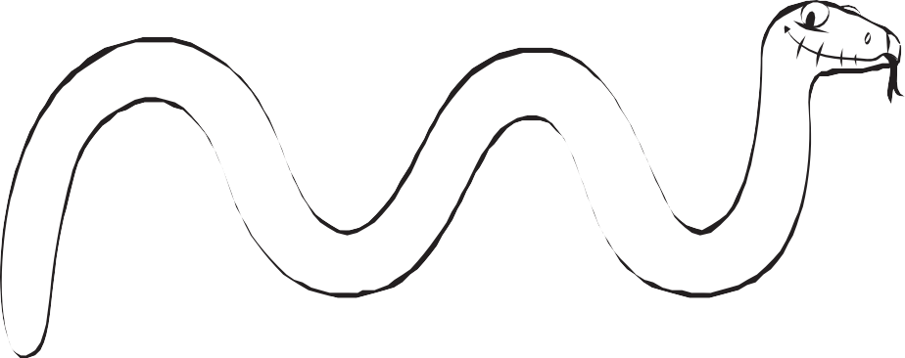
- Two words for hair style.
- Two words for hair length.
- Three words for eye colour.
- Two words for hair colour.
- Two words for eye size.

2 Read and write the family member.

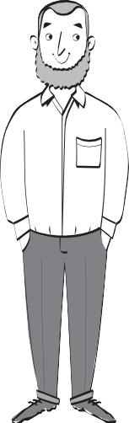
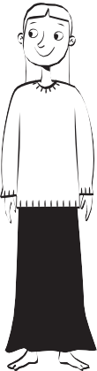
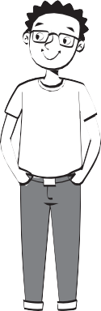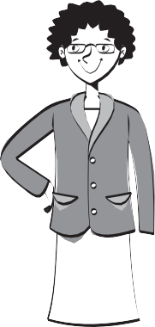Mum Dad Brother Sister

- She hasn’t got curly hair.
- He’s got short curly hair.
- She’s got glasses.
- He hasn’t got a beard.
- He’s got straight blond hair.
- She hasn’t got long hair.

3 Look at the picture. Write True or False.

  - My dad’s wearing trousers and a shirt.
  - My dad’s wearing trainers.
  - My mum’s wearing a jumper.
  - My mum’s wearing a skirt.
  - My sister isn’t wearing shoes.
  - My brother’s wearing trainers.
  - My sister’s wearing a jacket.
  - My brother isn’t wearing a jumper.

ork and play
W

Name
Catch-up

1 Find and number.

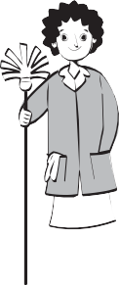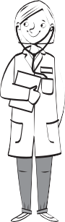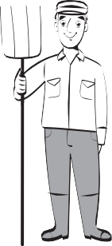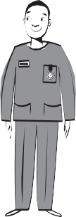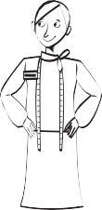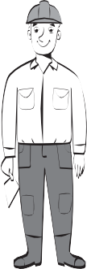
6

1 | a nurse | 2 | a doctor | 3 | a reporter | 4 a farmer
5 | a builder | 6 | a cleaner | 7 | a lawyer | 8 a vet
9 | a shop assistant |  | 10 | an office worker
2 Find and write.

    - This person is between the builder and the cleaner.
    - This person is next to the lawyer. He’s wearing gloves.
    - This person is next to the nurse. She’s got glasses.
    - This person is between the reporter and the farmer.

      - 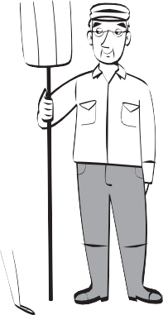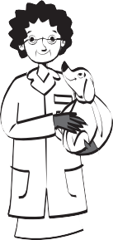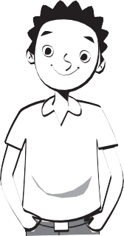Harry’s mum is a doctor.
3 Look and write.
mum
aunty
uncle
dad
Harry
      - His dad is an

 |  | 3
 |  | 4
granny | grandad | 5
 |  | 6

ork and play
W

Name
Support

1 Match.
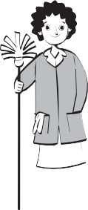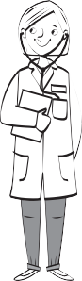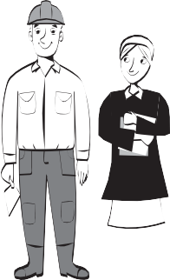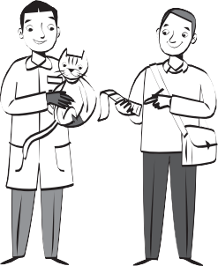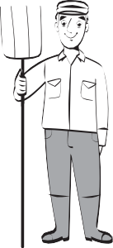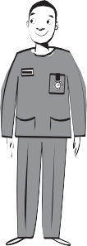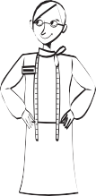a builder a cleaner a doctor a farmer an office worker

a lawyer a nurse a reporter a shop assistant a vet
2 Read and circle.
- The cleaner is next to the doctor / vet .
- The vet is next to the shop assistant / lawyer .
- The farmer is next to the builder / nurse .
- The office worker is next to the cleaner / reporter .
- The shop assistant is next to the cleaner / nurse .
3 Look and write.

  - 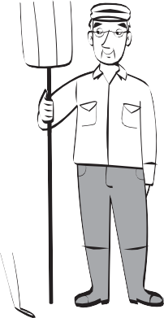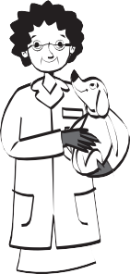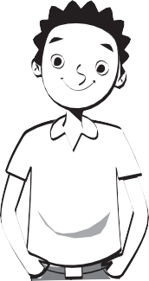Harry’s mum is a doctor.
mum
aunty
uncle
dad
granny
grandad
Harry
  - His dad is an
  - His aunty is a
  - His uncle is a
  - His granny is a
  - His grandad is a

y city
M

Name
Catch-up

1 Find the words and write.
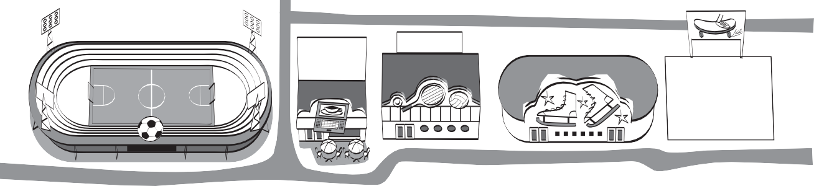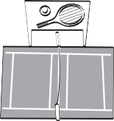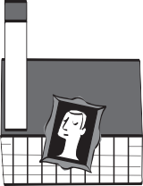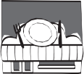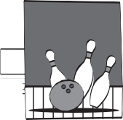
1
2
3
4
5
8
6
7
9
10

1 football stadium 2 cafe 3 centre
4 rink 5 park 6 court 7 gallery
8 9 alley 10 centre

2 Look and write the place.

next to
- It’s next to the tennis court. art gallery
between
opposite

- It’s between the art gallery and the bowling alley.
- It’s opposite the shopping centre.
- It’s next to the football stadium.
- It’s between the skate park and the sports centre.
- It’s opposite the restaurant.
3 Write about your town. Use There’s or There isn’t.

1 (restaurant) | †here’∫ a restaurant.
2 (internet cafe)
3 (ice rink)
4 (shopping centre)
5 (art gallery)
6 (tennis court)

y city
M

Name
Support

1 Look and circle.
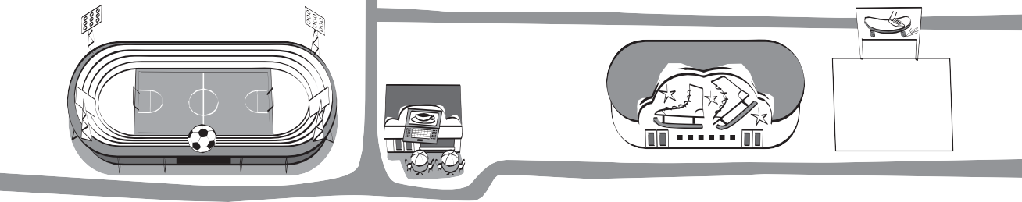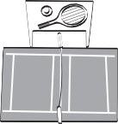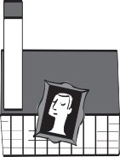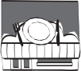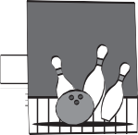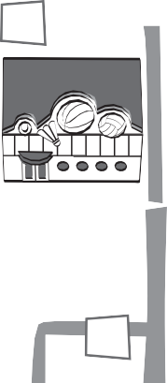
1
3
4
5
2
6
7
8
9
10

- tennis

stadium
football
- skate

cafe
- shopping

centre

- ice

- sports
internet sports

- football

- bowling

rink
park
court
gallery

art skate tennis art

- restaurant

cafe
- bowling

alley
- sports

centre

internet skating shopping
2 Read and number.

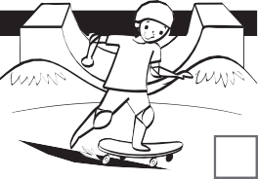
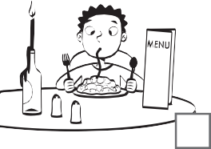
- 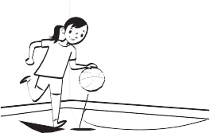She’s at the football stadium.
5
- He’s at the skate park.
- She’s at the art gallery.
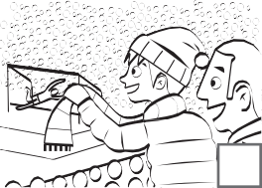
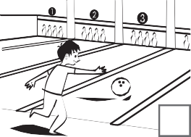
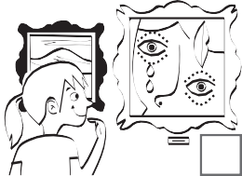
- He’s at the restaurant.
- She’s at the sports centre.
- He’s at the bowling alley.

3 Look and write.

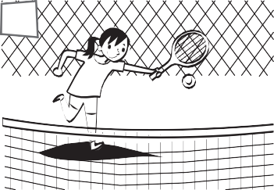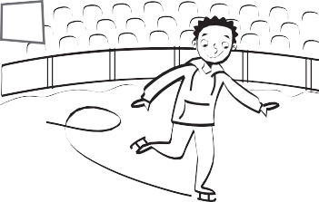1 She’s at the
1
2

2

ports and hobbies
S

Name
Support

1 Match.
doing aerobics doing judo doing gymnastics windsurfing snowboarding

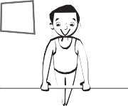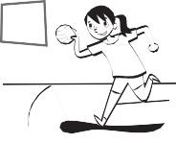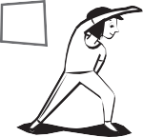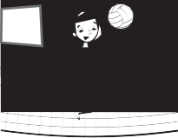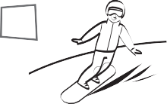
1
2
3
4
5
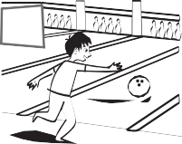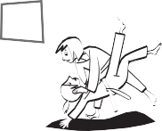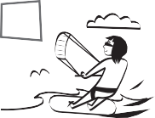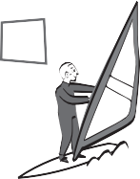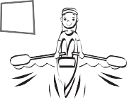
6
7
8
9
10

bowling playing handball rowing playing volleyball kitesurfing

2 Read and circle.
1
2

- He likes playing / doing gymnastics.
- 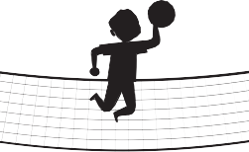She likes playing / doing handball.
3
4
- She likes playing / doing aerobics.
- He likes playing / doing volleyball.
- She likes playing / doing judo.
5

3 Look and write.

- 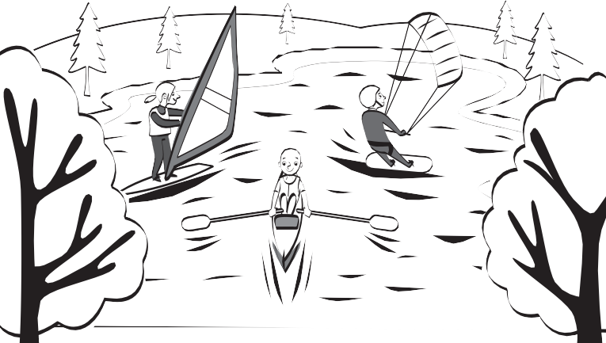He likes
- She likes
- She likes

nimals
A

Name
Support

1 Circle.
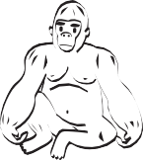
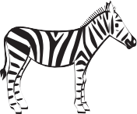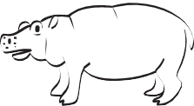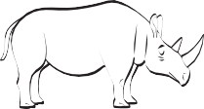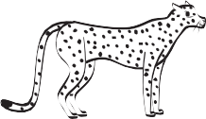
1
2
3
4
5

a zebra  a cheetah | a panda  a hippo | a gorilla  a rhino | a cheetah  a koala | a spider  a gorilla
6 | 7 | 8 | 9 | 10

a panda | a kangaroo | a kangaroo | an ant | an ant
a cheetah | a zebra | a koala | a spider | a hippo
2 Read and tick ✓ or cross ✗.

  - 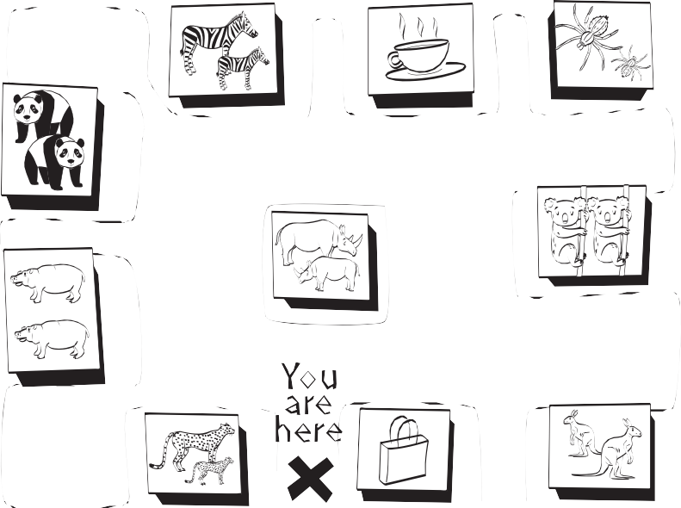There are some hippos.
✓
  - There aren’t any ants.
  - There are some gorillas.
  - There aren’t any gorillas.
  - There are some ants.
  - There are some cheetahs.

3 Look at the picture of the zoo. Write sentences.
ants spiders gorillas zebras

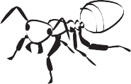
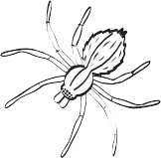
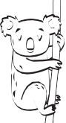
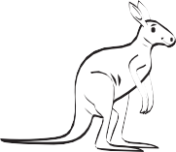
- There are some spider∫.
- There are some
- There aren’t any
- There aren’t any

